UNCOVERING THE GAMING

INDUSTRY’S HIDDEN GEMS

A COMPREHENSIVE ANALYSIS OF

VIDEO GAME SALES



INTRODUCTION:

Video game sales analysis is the process of collecting and analysing data the sales of video games in order to understand market trends and consumer behaviour. This type of analysis can be useful for a variety of purposes, including identifying the most popular games and genres, predicting future sales and developing marketing strategies. Video game sakes analysis typically involves collecting data from Kaggle sources. It was generated by a scrape of vgchartz.com. This data may include information about the number of units sold, the retail price, and the platforms on which the games are played. Once the data has been collected, it is typically analysed using tableau. The results of the analysis can be used to identify trends and patterns in the market, and to make informed decisions about the development and marketing of video games. Video game sales analysis may be conducted by game developers, publishers, retailers and other industry professionals. It is an important part of the video game industry, as it helps to understand the needs and preferences of consumers and to identify opportunities for growth and innovation.

PROBLEM DEFINITION AND DESIGN THINKING

EMPATHY MAP:

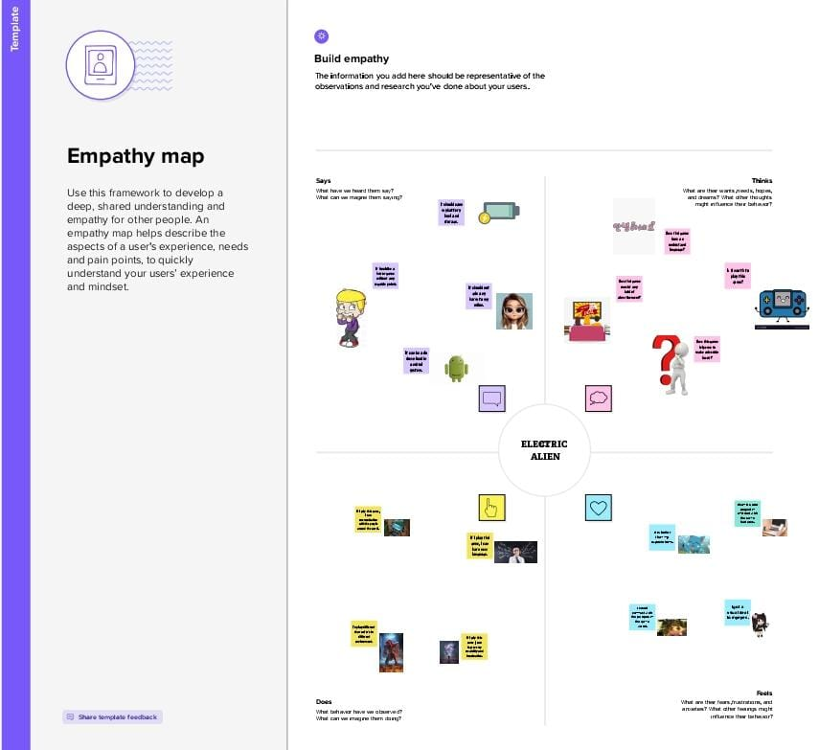

IDEATION AND BRAINSTORMING MAP:

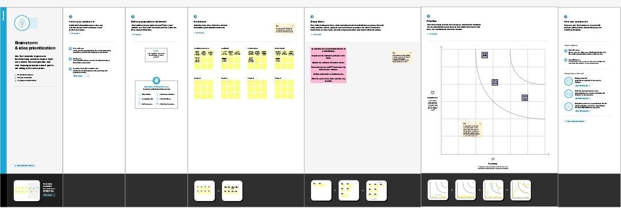

RESULT:

DASHBOARD:

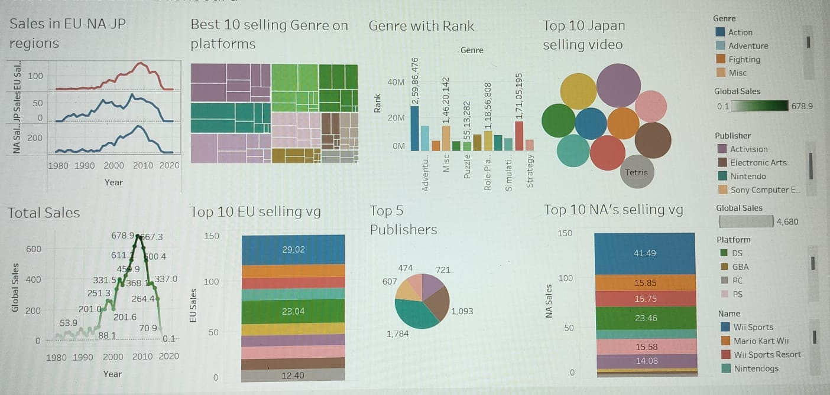

STORY:

1.

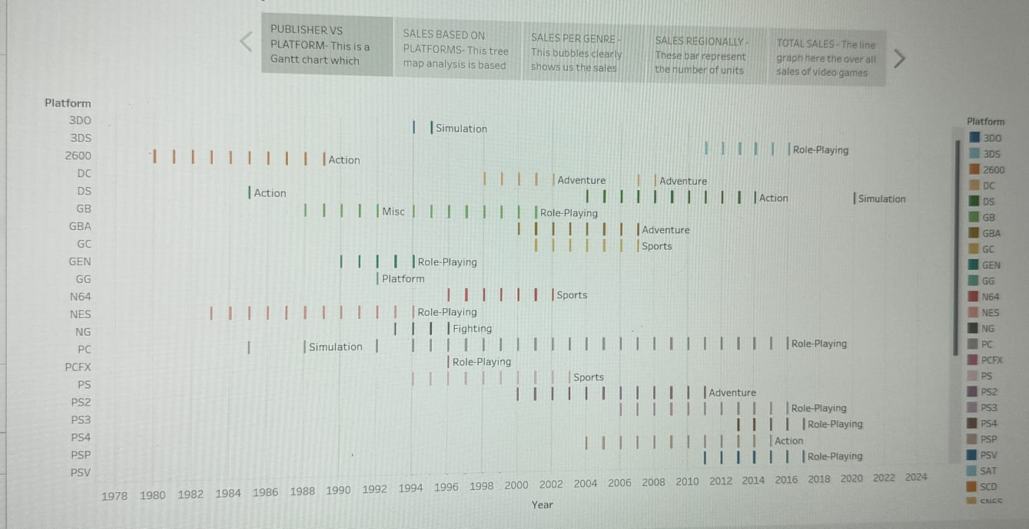

2.

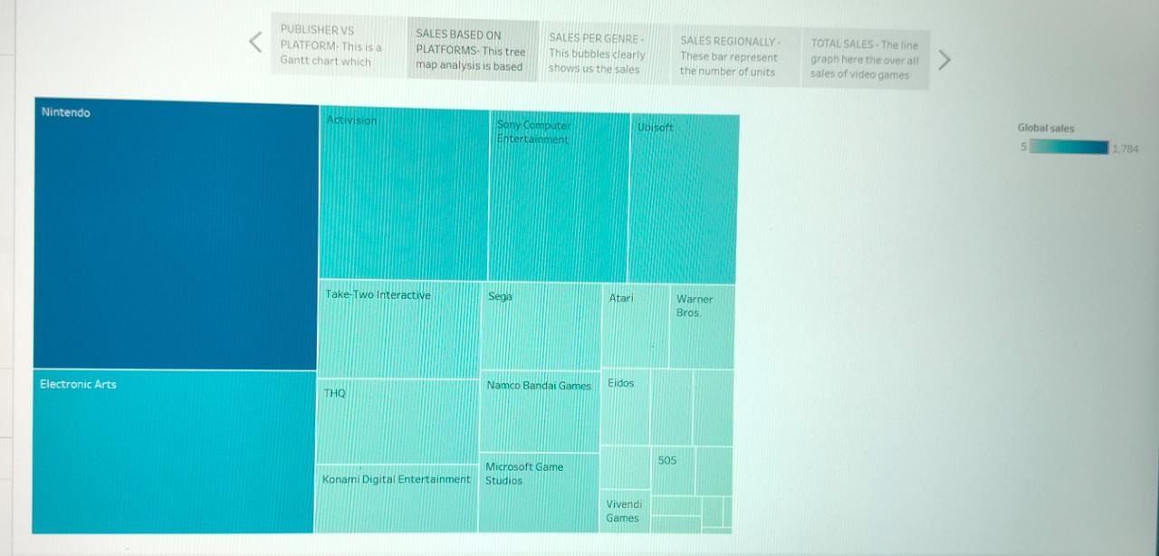

3. 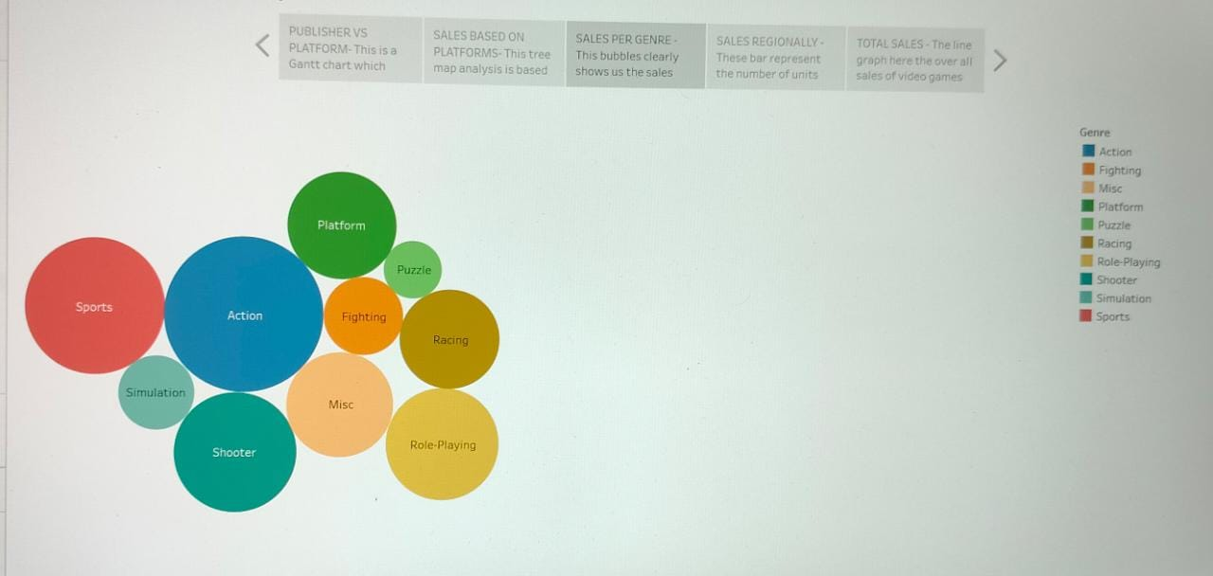

4.

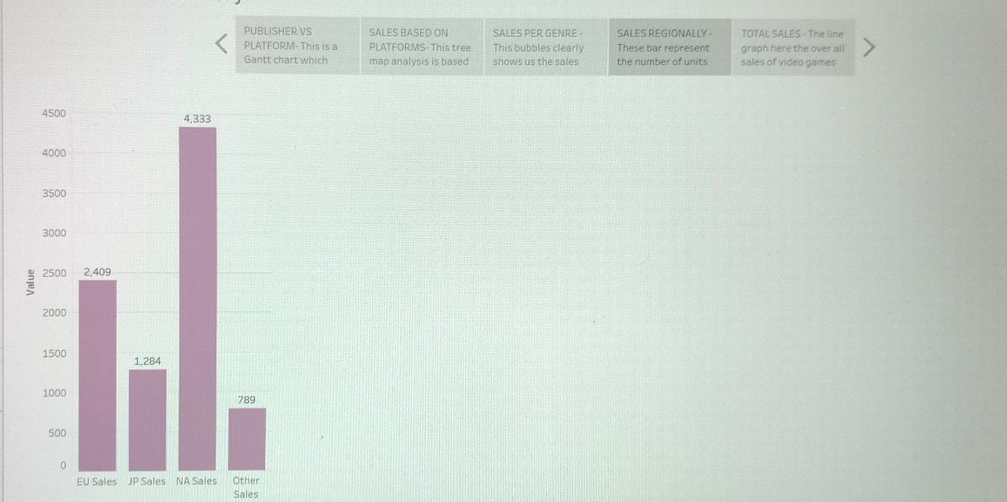

5.

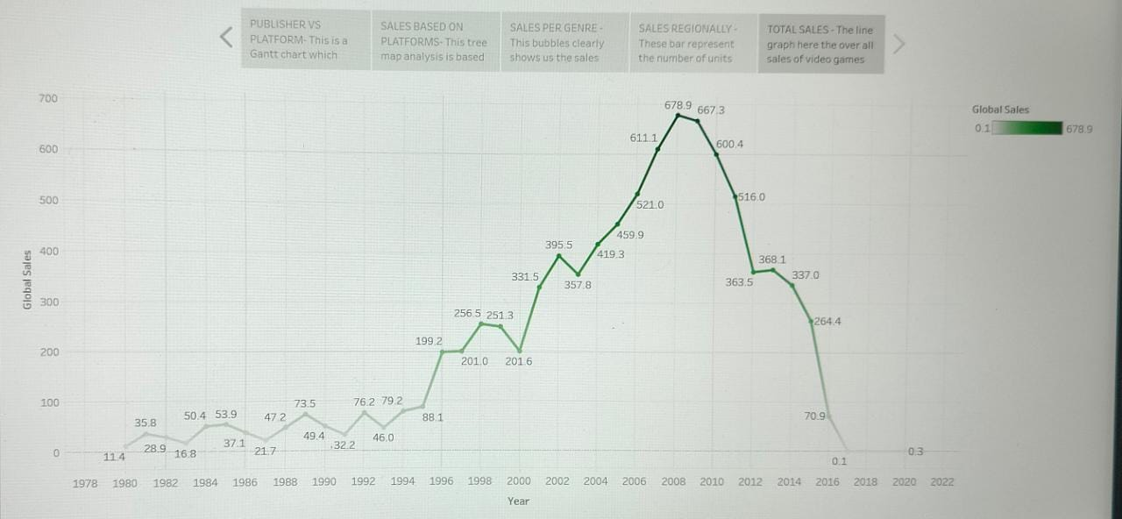

ADVANTAGES OF VIDEO GAME ANALYSIS:

They speed up response times;

Researchers at Rochester University have found that they improve troubleshooting skills by posing problems that must be solved in a set time.

They encourage teamwork;

According to Californian organisation, the Institute for the Future (IFTF), multiplayer games boost teamwork in problem solving.

They stimulate creativity, focus and visual memory;

The University of California has found that they stimulate these aspects by setting goals that require concentration, imagination and remembering details to achieve them.

They improve strategy and leadership;

Video games put players in command, honing their abilities to resolve disputes, interact with other players and make decisions, found Pittsburgh University.

They teach languages;

Helsinki University found that they are useful for learning other languages through on-screen instructions, chats for communicating with other players or the narration of the story itself.

Critical thinking;

Monterrey Institute of Technology published an article underlining the underlying ethical, philosophical and social basis of these games, and their ability to make players think and improve their critical thinking.

APPLICATION OF VIDEO GAME ANALYSIS:

Game development applications and tools can help game developers and creators make realistic games with advanced features. Both beginner and advanced game developers use these tools to enhance the quality and performance of their games. Knowing about some popular game development tools can help you make better games and increase the quality of your work output. In this article, we discuss the utility and advantages of game development software tools, list six popular tools and share some tips on selecting a suitable application as per your requirements.

What Are Game Development Software Applications?

Game development software applications are tools that help game developers make video games. They typically simplify processes such as converting assets, designing, level editing, compilation, simulation, testing and debugging. It is important to note that game development tools and applications typically get designed for one game and re-used for other games by the same developer or company. These tools usually have no value for regular game players, and outside of the development team, they have very few applications.

Game development tools help game designers and developers create concepts, characters and environments. Usually, some coding is required to convert these elements into a consistent video game. These tools are helpful for beginner and expert game developers as they can help expedite processes by automating the code for common game features. Using such tools, game developers can create gameplay physics, characters, menus, effects, buttons and links.

FUTURE SCOPE:

The future of the video game industry looks dazzling. Consumer demand is growing, technology is advancing quickly, and new monetization models are taking off. Bain’s analysis forecasts that global revenue for games could grow by more than 50% over the next five years.

Three big trends are changing the video game industry: better technology, metaverse-style environments, and new monetization models.

As competition increases, scale will become even more important, since big games are expensive to make and require a massive global audience to succeed.

Good franchise management and fan engagement also will become more critical than ever, prompting leading companies to put it at the center of decisions.

Success will require finding and keeping the best creative and technical talent—a challenge in an industry that’s losing developers to larger tech companies.

CONCLUSION:

Video games are a form of media that is often associated with negative health consequences. However, when games are played in moderation and with mindfulness, they are a viable source of stress relief as well as a catalyst for mental health improvement and development of social skills. Video games themselves are a relatively modern form of entertainment. They are engaging and immersive on a level different from that of traditional board games and other forms of entertainment. The player actively contributes to the level of satisfaction he/she attains from this medium and thus is more invested and willing to engage in the elements of the video game. The amount of play time is also an important factor in the effects of gaming. Although excessive playtime can have negative consequence, gaming in moderation can be healthy, fun, and educational.